
W-16
12 PHYSICS ATAR
TEST 5 - GRAVITATION

NAME: MARK:
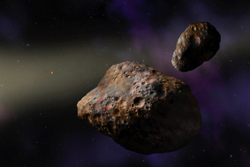
1. An asteroid of mass 2.55 x 10²² kg and diameter of 772 km
orbits the sun with a speed of 17.9 kms⁻¹.

(a) Calculate the gravitational field strength at any point on the surface of the asteroid? [4 marks]

(b) Calculate the orbital radius of the asteroid. [3 marks]

(c) With what force does the asteroid attract the sun? [4 marks]

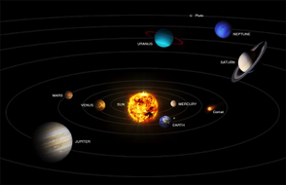
2. The solar system consists of a number of planets in approximately
circular orbits around the sun. The quotient, r³ /T², for each planet
has the same value.

(a) Show, by using algebraic manipulation of the equations learned in class, that the relationship r³ /T², is a constant value. [4 marks]

(b) What is the numerical value of this constant r³/T²? [3 marks]

(c) Mercury takes 88 days to orbit the sun, while Venus takes 225 days. Calculate the maximum distance that could ever exist between Mercury and Venus.
(If you did not calculate a value in part (b), use a value of 4x10¹⁸.) [5 marks]

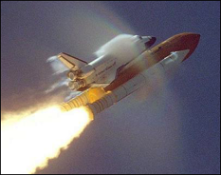
3. Just after lift-off a space shuttle rocket is accelerating vertically upwards. An astronaut inside states that she feels heavier.

(a) Explain, in terms of the forces acting on her, why she feels heavier. [3 marks]

(b) As the shuttle continues to accelerate vertically upwards, at the same rate, she notices she feels her weight decreasing. Explain why. [3 marks]

(c) The space shuttle launches from Cape Canaveral, Florida, USA. This is the location on mainland USA, closest to the equator. Explain how this might assist with the launch. [3 marks]

4. Callisto is the largest moon orbiting Jupiter. Callisto takes 16 days to complete each orbit, at a distance of 1.88 x 10⁹ metres from the centre of Jupiter. Use this data to calculate the mass of Jupiter. [4 marks]

5. The planet Mercury has a radius of 1.30 x 10⁶ m, a mass of 3.30 x 10²³ kg and its day is 58.65 Earth days. A 25.0 kg satellite is positioned into a geostationary orbit. How high above the surface of Mercury is the satellite orbiting? [6 marks]

6. The table shown below gives astronomical data for a planet currently orbiting the Sun.

Mass: 1.90 X 10²⁷ kg (317.9 Earths)
Radius (equatorial): 71 492 km
Mean density: 1.33 gcm⁻³
Distance from Sun: 778 330 000 km
Rotational period: 0.4135 days
Orbital Period: 4332.71 days
Apparent magnitude: -2.70
Surface temperature: -121°C (cloud)
Atmospheric composition: hydrogen (90%), helium (10%)

(a) What is the least massive planet in the solar system? [1 mark]

(b) Calculate the escape velocity of the planet Jupiter. [4 marks]

